 

**GRU BASED IoT SYSTEM FOR EARLY HEART FAILURE PREDICTION**

**A PROJECT REPORT**

***Submitted by***

**S.SOFIA (913120105037)**

**M.NITHYASHRI (913120105022)**

**K.SUREKA HARINI (913120105038)**

***In partial fulfillment for the award of the degree***

***of***

**BACHELOR OF ENGINEERING**

***in***

**ELECTRICAL AND ELECTRONICS ENGINEERING**

**VELAMMAL COLLEGE OF ENGINEERING AND TECHNOLOGY,**

**MADURAI-625 009**

**ANNA UNIVERSITY::CHENNAI 600 025**

**MAY 2024**

## ANNA UNIVERSITY: CHENNAI 600 025

## BONAFIDE CERTIFICATE

Certified that is report **“ GRU - BASED IoT SYSTEM FOR EARLY HEART FAILURE PREDICTION”** is the Bonafide work of **S.SOFIA (913120105037), M.NITHYASHRI (913120105022)** and **K.SUREKA HARINI (913120105038)** who carried out the project under my supervision.

##### SIGNATURE SIGNATURE

**Dr.A.SHUNMUGALATHA, M.E., Ph.D., Mrs.V.UMAYAL MUTHU,M.E.,(Ph.D)**

##### Head of the Department Assistant Professor-I

Electrical and Electronics Engineering, Electrical and Electronics Engineering, Velammal College of Engineering and Velammal College of Engineering and Technology, Technology,

Madurai–625009. Madurai –625009.

Certified that the candidate was examined on the Viva-Voce Examination held at Velammal College of Engineering and Technology, Madurai on .

**INTERNAL EXAMINER EXTERNAL EXAMINER**

**ACKNOWLEDGEMENT**

First of all we thank the Almighty for strengthening us throughout the project and helping us to complete it successfully.

We find immense pleasure to convey our sincere thanks to our honorable Principal **Dr.P.ALLI ,** for providing necessary facilities in carrying out our project work in our campus.

We would like to express our hearty thanks to our Head of the Department **Dr.A.SHUNMUGALATHA, M.E., Ph.D.,** for her constant encouragement.

We take this opportunity to express our sincere and heartfelt thanks to our guide, **Mrs.V.UMAYAL MUTHU, M.E., (Ph.D)** for her patient guidance, timely suggestion technical and moral support and the immense part of her dedication in completing the project work successfully.

We express our special thanks to other staff members of our department, the non-teaching staff and our friends who assisted us, by their support and encouragement.

We also express our special thanks to our Parents who have sacrificed greatly in our education and welfare. We thank all those who have helped directly and indirectly in doing this project and bringing out this successful report.

**ABSTRACT**

Wearable devices have gained significant traction in the healthcare domain for their potential in continuous health monitoring. In this study, we propose a novel wearable device equipped with SpO2 (Blood Oxygen Saturation) and temperature sensors to monitor vital signs such as pulse rate and oxygen levels. Leveraging advancements in deep learning, specifically Gated Recurrent Units (GRUs), we present a methodology for the classification of heart disease into normal and abnormal categories based on the collected physiological data.The wearable device continuously measures SpO2 levels, temperature, and pulse rate from the wearer. The gathered data are preprocessed and fed into a GRU-based neural network architecture. The GRU model is trained on a dataset comprising samples of individuals diagnosed with normal heart function and those with various heart abnormalities. Through this training process, the model learns to extract meaningful patterns from the temporal dynamics of the physiological signals.The performance of the proposed system is evaluated using standard metrics such as accuracy, sensitivity, specificity, and area under the receiver operating characteristic curve (AUC-ROC). Our experimental results demonstrate promising classification accuracy in distinguishing between normal and abnormal heart conditions. Moreover, the use of GRUs enables the model to capture long-term dependencies inherent in physiological time series data, enhancing the robustness and effectiveness of the classification task.Overall, this research contributes to the development of wearable healthcare technologies for early detection and monitoring of cardiovascular diseases. The integration of SpO2 and temperature sensors with GRU-based deep learning models offers a non-invasive and efficient approach for heart disease classification, potentially empowering individuals to proactively manage their cardiovascular health.

**LIST OF CONTENTS**

|  |  |  |
| --- | --- | --- |
| **CHAPTER NO.** | **TITLE** | **PAGE NO.** |
|  | **ACKNOWLEDGEMENT** | **iii** |
|  | **ABSTRACT** | **iv** |
|  | **LIST OF CONTENTS** | **v** |
|  | **LIST OF FIGURES** | **vii** |
|  | **LIST OF ABBREVATION** | **x** |
| **1** | **INTRODUCTION** | **1** |
|  | 1.1 GENERAL | 1 |
|  | 1.2 OBJECTIVE | 3 |
|  | 1.3 EXISTING METHOD | 4 |
|  | 1.3.1 DRAWBACK | 4 |
| **2** | **LITERATURE SURVEY** | **5** |
|  | 2.1 RFID BASED PROTECTION TO  NEWBORNS IN THE HOSPITALS | 5 |
|  | 2.2 ACTIVE RFID BASED INFANT  SECURITY SYSTEM | 6 |
|  | 2.3 RFID APPLICATION INFANT SECURITY  SYSTEMS OF HEALTHCARE  ORGANIZATIONS | 7 |
|  | 2.4 AN INTELLIGENTLY REMOTE INFANT  MONITORING SYSTEM BASED ON  RFID | 8 |
| **3** | **PROPOSED SYSTEM** | **9** |
|  | 3.1 DESCRIPTION | 9 |
|  | 3.2 BLOCK DIAGRAM DESCRIPTION | 10 |
|  | 3.3 ADVANTAGES | 11 |
| **4** | **MODULE DESCRIPTION** | **12** |
|  | 4.1 POWER SUPPLY | 12 |
|  | 4.2 TRANSFORMER | 13 |
|  | 4.3 ARDUINO UNO CONTROLLER | 13 |
|  | 4.4 LIMIT SWITCH | 19 |
|  | 4.5 LDR SENSOR | 19 |
|  | 4.6 RFID (RADIO FREQUENCY  IDENTIFICATION) | 20 |
|  | 4.7 KEYBOARD ENCODER | 21 |
|  | 4.8 BUZZER | 21 |
|  | 4.9 VOICE BANK | 22 |
|  | 4.10 LCD DISPLAY | 23 |
| **5** | **RESULTS AND DISCUSSION** | **24** |
|  | 5.1 RESULTS | 24 |
|  | 5.2 COST ESTIMATION | 27 |
| **6** | **CONCLUSION** | **28** |
| **7** | **REFERENCES** | **29** |
| **8** | **PUBLICATION** | **31** |

**LIST OF FIGURES**

|  |  |  |
| --- | --- | --- |
| **FIGURE**  **NO.** | **DESCRIPTION** | **PAGE**  **NO.** |
| 2.1 | RFID system block diagram | 5 |
| 2.2 | Topological structure of the Infant Security System | 6 |
| 2.3 | Flowchart | 7 |
| 3.1.1 | Block diagram of the proposed system | 9 |
| 4.1.1 | 7085 Regulator IC Pin | 13 |
| 4.2.1 | Transformer | 13 |
| 4.3.1 | Arduino Board | 14 |
| 4.4.1 | Limit Switch | 19 |
| 4.5.1 | LDR Sensor | 20 |
| 4.6.1 | RFID Reader | 20 |
| 4.7.1 | Keyboard Encoder | 21 |
| 4.8.1 | Buzzer | 22 |
| 4.9.1 | Voice Bank | 22 |
| 4.10.1 | LCD Display | 23 |
| 5.1.1 | Implemented Prototype | 24 |
| 5.1.2 | LCD displaying the information for the RFID tag verification | 24 |
| 5.1.3 | LCD displaying the information for the RFID tag verification | 25 |
| 5.1.4 | LCD displaying the authorized person | 25 |
| 5.1.5 | LCD displaying the passkey window | 25 |
| 5.1.6 | LCD displaying the verification completion process | 25 |
| 5.1.7 | LCD displaying the denial of authority | 26 |
| 5.1.8 | Buzzer | 26 |
| 5.1.9 | Speaker | 26 |

**LIST OF ABBREVATION**

* **RFID -**  Radio Frequency Identification
* **LDR -** Light Dependent Resistor
* **LCD -** Light Crystal Display
* **IC -** Integrated chip
* **EAC -** Electronic Access Control
* **IT -** Information Technology
* **PIR -** Passive Infrared Sensor
* **USB -** Universal Serial Bus
* **PWM -** Pulse Width Modulation
* **LED -** Light Emitting Diode

**CHAPTER 1**

**INTRODUCTION**

**1.1 GENERAL**

Today, Internet application development demand is very high. So IoT is a major technology by which we can produce various useful internet applications.

Basically, IoT is a network in which all physical objects are connected to the internet through network devices or routers and exchange data. IoT allows objects to be controlled remotely across existing network infrastructure. IoT is a very good and intelligent technique which reduces human effort as well as easy access to physical devices. This technique also has autonomous control feature by which any device can control without any human interaction.

The above figure shows the connectivity of various devices of different fields with Internet and exchange data between them. So above figure represent the connectivity of world through various existing technologies.

“Things” in the IoT sense, is the mixture of hardware, software, data, and services. “Things” can refer to a wide variety of devices such as DNA analysis devices for environmental monitoring, electric clamps in coastal waters, Arduino chips in home automation and many other. These devices gather useful data with the help of various existing technologies and share that data between other devices. Examples include Home Automation System which uses Wi-Fi or Bluetooth for exchange data between various devices of home.

This work focuses on the development and evaluation of a wearable device equipped with SpO2 and temperature sensors, aiming to classify heart disease into normal and abnormal categories utilizing Gated Recurrent Units (GRUs) in deep learning. The scope encompasses the design, prototyping, and testing of the wearable device, as well as the implementation of data preprocessing algorithms and GRU-based neural network architecture for heart disease classification.

The wearable device will be designed to continuously monitor SpO2 levels, temperature, and pulse rate, providing real-time data acquisition for analysis. The preprocessing algorithms will be developed to clean and normalize the collected physiological data, ensuring accuracy and reliability in subsequent classification tasks. The GRU-based neural network architecture will be tailored to learn temporal patterns from the physiological signals, enabling effective classification of heart disease.

The scope also includes the collection and curation of a diverse dataset containing samples from individuals diagnosed with normal heart function and those with various heart abnormalities. Training, validation, and testing of the GRU model will be conducted using this dataset to evaluate its performance in terms of classification accuracy, sensitivity, specificity, and AUC-ROC.

Additionally, the feasibility and usability of the wearable device will be assessed in real-world scenarios, considering factors such as comfort, portability, and battery life. The study will explore the potential applications of the proposed technology in healthcare settings, with implications for early detection, monitoring, and management of cardiovascular diseases.While the primary focus is on heart disease classification using SpO2 and temperature sensors with GRU-based deep learning, this study lays the groundwork for future research in wearable healthcare technologies and their integration into personalized health monitoring systems.

**1.2 OBJECTIVE**

The aim of this work is to develop a wearable device integrated with SpO2 and temperature sensors for continuous monitoring of physiological parameters, namely blood oxygen saturation, temperature, and pulse rate. The primary objective is to leverage these sensors to classify heart disease into normal and abnormal categories, employing advanced deep learning techniques, particularly Gated Recurrent Units (GRUs).

Specific objectives include:

1. Designing and prototyping a wearable device capable of real-time acquisition of SpO2 and temperature data, along with pulse rate measurements.

2. Developing preprocessing algorithms to clean and normalize the collected physiological data for subsequent analysis.

3. Implementing a GRU-based neural network architecture for learning temporal patterns from the physiological signals.

4. Training the GRU model using a diverse dataset containing samples from individuals diagnosed with normal heart function and those with various heart abnormalities.

5. Evaluating the performance of the proposed system in terms of classification accuracy, sensitivity, specificity, and AUC-ROC.

6. Investigating the effectiveness of the integrated SpO2 and temperature sensors alongside GRU-based deep learning for heart disease classification.

7. Assessing the feasibility and usability of the wearable device in real-world scenarios, considering factors such as comfort, portability, and battery life.

By achieving these objectives, this research aims to contribute to the advancement of wearable healthcare technologies for early detection and monitoring of cardiovascular diseases, ultimately promoting proactive management of cardiovascular health and improving patient outcomes.

access control (EAC). CCTV/camera system, pagers, beepers or any other mobile device carried by caregivers, and IOS or Android devices.

**1.3 EXISTING METHOD**

The existing healthcare monitoring systems often face limitations in providing real-time, remote monitoring of patients' vital signs, especially during epidemic outbreaks like the novel coronavirus. Traditional monitoring methods may not efficiently capture and transmit crucial health data, leading to delays in diagnosis and treatment. Moreover, the lack of integration with advanced technologies such as Internet of Things (IoT) and machine learning hampers the system's ability to provide timely insights and responses.

The current healthcare infrastructure lacks a comprehensive solution that seamlessly integrates IoT-based monitoring with advanced analytics to enable efficient disease prevention, diagnosis, and management. There is a need for a system that can continuously monitor patients' vital signs, such as heartbeat, temperature, and oxygen levels, in real-time and transmit this data securely to healthcare professionals, regardless of their location. Additionally, the existing systems often lack robustness and scalability, making them inadequate for handling the surge in demand during epidemic outbreaks.

Furthermore, the absence of a unified platform for storing, analyzing, and interpreting the collected health data impedes the timely identification of disease severity and appropriate intervention strategies. Without leveraging machine learning algorithms capable of processing vast amounts of data and providing actionable insights, healthcare providers may struggle to prioritize and allocate resources effectively.

Therefore, there is an urgent need to develop an advanced, IoT-based health monitoring system that addresses these shortcomings and provides a holistic solution for epidemic management. Such a system would enable real-time monitoring, early detection of symptoms, and timely intervention, ultimately improving patient outcomes and reducing the burden on healthcare systems.

**DRAWBACKS**

* Traditional statistical methods and limited integration of IoT devices for data collection.
* Limited capability to handle imbalanced datasets.
* Accuracy varies based on the selected method and dataset.
* Delayed detection due to limited monitoring capabilities..

**CHAPTER 2**

**LITERATURE SURVEY**

# Title: A Medical-History-Based Potential Disease Prediction Algorithm

**Year: 2019**

**Author:** [**Wenxing Hong**](https://www.researchgate.net/profile/Wenxing-Hong?_tp=eyJjb250ZXh0Ijp7ImZpcnN0UGFnZSI6InB1YmxpY2F0aW9uIiwicGFnZSI6InB1YmxpY2F0aW9uIn19)**, Ziang Xiong and Nanan Zheng**

W. Hong intends to use healthcare big data analysis combined with deep learning technology to provide patients with potential diseases which is usually neglected for lacking of professional knowledge, so that patients can do targeted medical examinations to prevent health condition from getting worse. Inspired by the existing recommendation methods, this paper proposes a novel deep-learning-based hybrid recommendation algorithm, which is called medical-history-based potential disease prediction algorithm. The algorithm predicts the patient's possible disease based on the patient's medical history, providing a reference to patients and doctors to reduce the problem of delaying treatment due to unclear description of the symptom or limited professional knowledge. The experimental results show that our approach improves the accuracy of the potential diseases prediction.

.

**Title: Development of Smart Healthcare Monitoring System in IoT Environment**

**Year: 2020**

**Author:** [**Md. Milon Islam**](https://link.springer.com/article/10.1007/s42979-020-00195-Y#auth-Md__Milon-Islam-Aff1)**,** [**Ashikur Rahaman**](https://link.springer.com/article/10.1007/s42979-020-00195-Y#auth-Ashikur-Rahaman-Aff1)**&**[**Md. Rashedul Islam**](https://link.springer.com/article/10.1007/s42979-020-00195-Y#auth-Md__Rashedul-Islam-Aff1)

Islam MM et al proposes a smart healthcare system in IoT environment that can monitor a patient's basic health signs as well as the room condition where the patients are now in real-time. In this system, five sensors are used to capture the data from hospital environment named heart beat sensor, body temperature sensor, room temperature sensor, CO sensor, and CO2 sensor. The error percentage of the developed scheme is within a certain limit (< 5%) for each case. The condition of the patients is conveyed via a portal to medical staff, where they can process and analyze the current situation of the patients. The developed prototype is well suited for healthcare monitoring that is proved by the effectiveness of the system.

# Title: Cloud-assisted tracking medical mobile robot

**Year: 2017**

**Author: Huiru Cao, Runjie Chen, Yucheng Gu and Huizi Xu**

H. Cao, et al present a design for a cloud-assisted medical robot with mobility, which can remotely monitor and collect the parameters of human body. Moreover, the robot can upload this information to cloud and distribute it to a smart terminal in real-time. We construct the control and communication systems based on the main controller STM32 and WIFI, respectively. Further, user-friendly APPs are designed and a prototype of the mobile robot is built. Our proposed design approach can ensure the safety of elderly, reduce the burden of taking care of the elderly, and deal with emergency situate

**Title: An Intelligently Remote Infant Monitoring System Based On RFID**

**Year: 2012**

**Author: Shou-Hsiung Cheng**

This study proposes a straight forward and efficient intelligently remote infant monitoring system to reduce the potential risks of the theft, misuse hold and abnormal body temperature. The system can accurately recognizes the locations of newborn babies by using neutral network classifiers after the active RFID readers has received different intensity of electromagnetic waves transmitted by active RFID tags. The newborn babies of temperature anomalies also can be diagnosed by the body temperature sensors and the proposed infant monitoring system. The remote infant monitoring system improved infant care and safety, reduced systems and human-based errors and enabled fast communicating with the clinical staff and families. This system can be used infants at home or in a hospital nursery room.

**CHAPTER 3**

**PROPOSED SYSTEM**

**3.1 DESCRIPTION**

In this proposed method, a PIR sensor and baby presence detecting sensor (limit switch), RFID reader, Voice chip and keyboard encoder involved in this security system. If we want to lift the infant from cradle, we need to show the authorized ID card to the RFID reader. The reader will verify the card and ask for the password. The system authentication enables the authorized person to lift the baby. Infant can be accessed if the password matches otherwise the voice alert will be initiated to avoid kidnapping of baby. We also have a protection to give an alarm if anybody trying to bypass the entire system by cutting wires of our system power supply.

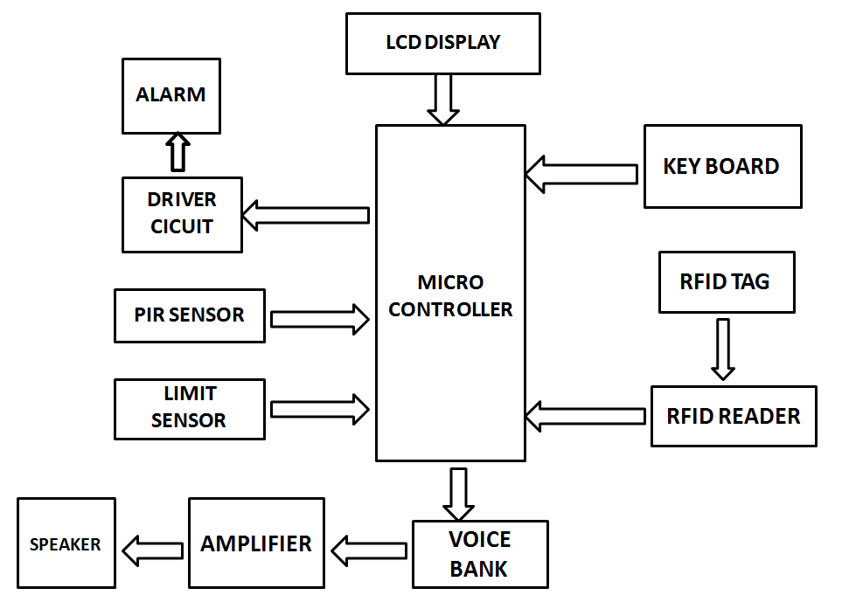

Fig. 3.1.1 Block Diagram of the proposed system

**3.2 BLOCK DIAGRAM DESCRIPTION**

A power supply circuit is very essential in any project. This power supply circuit is designed to get regulated output DC voltage. 7802 IC is used to give the constant 5v supply. Bridge rectifiers using diodes is used for rectifying purposes. The power supply section is for supplying voltages to the entire circuit unit.

The Arduino Uno is a microcontroller board based on the ATmega328. It has 14 digital input/output pins (of which 6 can be used as PWM outputs), 6analog inputs, a 16 MHz crystal oscillator, a USB connection, A power jack, an ICSP header, and a reset button. It contains everything needed to support the microcontroller.

RFID is a board term for technologies that use radio waves to automatically identify people or objects. There are several methods of identification, but the most common is to store a serial number that identifies a person or object, and perhaps other information, on a microchip that is attached to an antenna. The antenna enables the chip to transmit the identification information to a reader. The reader converts the radio waves back from the RFID tag into digital information that can then be passed on to computers that can make use of it.

A limit switch is an electromechanical device operated by a physical force applied to it by an object. Limit switches are used to detect the presence or absence of an object. These switches were originally used to define the limit of travel of an object.

LDR is also referred to as a photoresistor, photocell, or photoconductor. It is a specific kind of resistor, and the amount of light that strikes its surface affects how much resistance it exhibits. As the light level rises, the resistance value will decrease. As a result, these resistors are widely used in a variety of application due to this variation in resistance. The wavelength of the incident light affects the LDR sensitivity as well.

IC APR33 is used as the voice bank. The prerecorded messages can be stored in any location. This can be replayed by selecting the respective signal.

The piezoelectric type uses the piezoelectric ceramic’s piezoelectric effect and pulse current to make the metal plate vibrate and generate sound. This kind of buzzer is made with a resonance box, multi resonator, piezoelectric plate, housing, impedance matcher, etc. Some of the buzzers are also designed with LEDs.

LCD is essentially used for expose the information. Here we are using 2x16 LCD. It is used to display numbers, texts and graphics. This is in contrast to LEDs, which are limited to numbers and characters. The LCDs are fragile with only a few millimeter thickness. Since the LCDs utilize less power, they are efficient with low power electronic circuits, and can be charged for long terms. The LCDs don’t provoke light and so light is needed to read the display. The LCDs have long lasting life and a wide operating temperature range.

**3.3 ADVANTAGES**

* Tags are able to store more information per chip than a barcode, and wireless scanners that have the ability to instantly identify and capture data when within scanning range.
* RFID can also improve the efficiency in which healthcare providers are able to render care to their patient.
* Additionally, it was found that the RFID system benefited families in the waiting area, providing real-time information on their family member’s location, improving the efficiency in which families are updated, and improving service quality.

**CHAPTER 4**

**MODULE DESCRIPTION**

**4.1 POWER SUPPLY**

It is an electronics unit. This is used to give regulated power to any electronics system. This power supply circuit is designed to get regulated output DC voltage. The 9 volt transformer, step down the main voltage (230v) into 9 volts. The secondary voltage of transformer is rectified using bridge rectifier. The rectifies unidirectional DC is smoothed by 1000mf filter capacitor. The smooth DC is then fed to the three terminal +ve regulator called 7805 to get 5v DC supply.

Description:

1. Transformer: This block consist step-down transformer for our required ratings.
2. Rectifier: This block consist diode based rectifier circuit.
3. Filter circuit: This block consist capacitor based filter circuit.
4. Regulator: This block consists +ve (and) –ve three terminal regulators.

Circuit Operation:

The mains voltage ac 230v is step down to 9 volt, using 9v step down transformer. The low value secondary voltage is fed to the rectifier is formed using four no. of IN 4007. For first half cycle, Diodes D1 & D2 come to action and next half cycle diode D3 & D4 come to action, finally unidirectional dc supply is fed to the filter capacitor. The charging & discharging property of capacitor provide pure smooth dc is nearly peak value of the secondary voltage. The pure DC supply is fed to regulator IC’s input terminal. Due to the regulator action, finally, regulated 5 volts is available at output terminals.

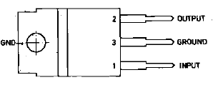

Fig. 4.1.1 7085 regulator IC pin

* 1. **TRANSFORMER**

The transformer, in a simple way, can be described as a device that steps up or steps down voltage. In a step-up transformer, the output voltage is increased, and in a step-down transformer, the output voltage is decreased. The step-up transformer will decrease the output current, and the step-down transformer will increase the output current to keep the input and output power of the system equal.

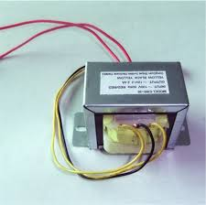

Fig. 4.2.1 Transformer

* 1. **ARDUINO UNO CONTROLLER**

The Arduino Uno is a microcontroller board based on the ATmega328. It has 14 digital input/output pins (of which 6 can be used as PWM outputs), 6 analog inputs, a 16 MHz crystal oscillator, a USB connection, a power jack, an ICSP header, and a reset button. It contains everything needed to support the microcontroller; simply connect it to a computer with a USB cable or power it with a AC-to-DC adapter or battery to get started. The Uno differs from all preceding boards in that it does not use the FRDI USB-to-serial driver chip. Instead, it features the Atmega8U2 programmed as a USB-to-serial converter.

Some of it’s features are:

* Microcontroller : ATmega328
* Operating Voltage : 5V
* Input Voltage (recommended) : 7-12V
* Input Voltage (limits) : 6-20V
* Digital I/O Pins : 14 (of which 6 provide PWM output)
* Analog Input Pins : 6
* DC Current per I/O Pin : 40mA
* DC Current for 3.3V Pin : 50mA
* Flash Memory : 32 KB of which 0.5 KB used by bootloader.
* SRAM : 2KB
* EEPROM : 1KB
* Clock Speed : 16 Mhz

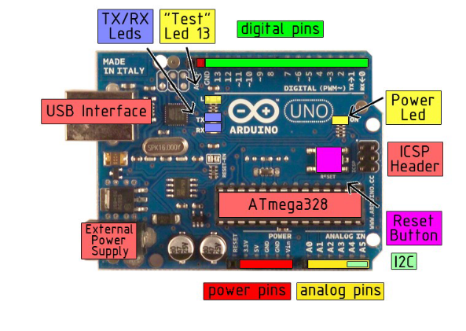

Fig. 4.3.1 Arduino board

The Arduino Uno can be powered via the USB connection or with an external power supply. The power source is selected automatically.

External (non-USB) power can come either from an AC-to-DC adapter (wall-wart) or battery. The adapter can be connected by plugging a 2.1mm center-positive plug into the board’s power jack. Leads from a battery can be inserted in the Gnd and Vin pin headers of the POWER connector.

The board can operate on an external supply of 6 to 20 volts. If supplied with less than 7V, however, the 5V pin may supply less than five volts and the board may be unstable. If using more than 12V, the voltage regulator may overheat and damage the board. The recommended range is 7 to 12 volts.

The power pins are as follows:

* **VIN.** The input voltage to the Arduino board when it’s using an external power source (as opposed to 5 volts from the USB connection or other regulated power source). You can supply voltage through this pin, or, if supplying voltage via the power jack, access it through this pin.
* **5V.** The regulated power supply used to power the microcontroller and other components o the board. This can come either from VIN via an on-board regulator, or be supplied by USB or another regulated5V supply.
* **3V3.** A 3.3 volt supply generated by the on-board regulator. Maximum current draw is 50mA.
* **GND.** Ground pins.

**MEMORY:**

The Atmega328 has 32KB of flash memory for storing code (of which 0.5 KB is used for the boot loader); It has also 2KB of SRAM and 1 KB of EEPROM.

**Input And Output:**

Each of the 14 digital pins on the Uno can be used as an input or output, using pin Mode(), digital Write(), and digital Read() functions. They operate at 5 volts. Each pin can provide or receive a maximum of 40mA and has an internal pull-up resistor (disconnected by default) of 20-5- kOhms. In addition, some pins have specialized

functions:

* **Serial: 0 (RX) and 1(TX).** Used to receive (RX) and transmit (TX) TTL serial data. These pins are connected to the corresponding pins of the ATmega8U2 USB-to-TTL Serial chip.
* **External Interrupts: 2 and 3.** These pins can be configured to trigger an interrupt on a low value, arising or falling edge, or a change in value.
* **PWM: 3,5,6,9,10, and 11.** Provide 8-bit PWM output with the analog Write() function.
* **SPI: 10 (SS), 11 (MOSI), 12 (MISO), 13 (SCK).** These pins support SPI communication, which, although provided by the underlying hardware, is not currently included in the Arduino language.
* **LED: 13.** There is a built-in LED connected to digital pin 13. When the pin is HIGH value, the LED is on, when the pin is LOW, it’s off.

The Uno has 6 analog inputs, each of which provide 10 bits of resolution (i.e. 1025 different values). By default they measure from ground to 5 volts, though is it possible to change the upper end of their range using the AREF pin and the analog Reference() function. Additionally, some pins have specialized

functionality:

* **I2C: 4 (SDA) and 5 (SCL).** Support I2C (TWI) communication using the Wire library.
* **AREF.** Reference voltage for the analog inputs. Used with analog Reference().
* **Reset.** Bring this line LOW to reset the microcontroller. Typically used to add a reset button to shields which block the one on the board.

Characteristics:

The maximum length and width of the Uno PCB are 2.7 and 2.1 inches respectively, with the USB connector and power jack extending beyond the former dimension. Three screw holes allow the board to be attached to a surface or case. Note that the distance between digital pins 7 and 8 is 160 mil (0.16’’), not an even multiple of the 100 mil spacing of the other pins.

Features:

* Advanced RISC Architecture
* 131 Powerful Instructions- Most Single Clock Cycle Execution
* 32 x8 General Purpose Working Registers
* Fully Static Operation
* Up to 20 MIPS Throughout at 20 MHz
* On-chip 2-cycle Multiplier
* High Endurance Non-volatile Memory Segments

ATMEGA:

The ATmega48PA328P AVR is supported with a full suite of program and system development tools including: C Compilers, Macro Assemblers, Program Debugger/Simulators, In-Circuit Emulators, and Evaluation kits.

Pin description of ATMEGA:

**VCC**

1 supply voltage.

**GND**

Ground

**Port B (PB&:0) XTAL!/XTAL2/TOSC1/TOSC2**

Port B is an 8=bit bi-directional I/O port with internal pull-up resistors (selected for each bit). The Port B output buffers have symmetrical drive characteristics with both high sink and source capability. As inputs, Port B pins that are externally pulled low will source current if the pull-up resistors are activated. The Port B pins are tri-stated when a reset condition becomes active, even if the clock is not running. Depending on the clock selection fuse settings, PB6 can be used as input to the inverting Oscillator amplifier and input to the internal clock operating circuit. Depending on the clock selection fuse settings, PB7 can be used as output from the inverting Oscillator amplifier.

If the Internal Calibrated RC Oscillator is used as chip clock source, PB7..6 is used as TOSC2..1 input for the Asynchronous Timer/Cpunter2 if the AS2 bit in ASSR is set.

**Port C (PC5:0)**

Port C is a 7-bit bi-directional I/O port with internal pull-up resistors (selected for each bit). The PC5..0 output buffers have symmetrical drive characteristics with both high sink and source capability. As inputs, Port C pins that are externally pulled low will source current if the pull-up resistors are activated. The port C pins are tri-stated when a reset condition becomes active, even if the clock is not running.

**PC6/RESET**

If the RSDTISBL Fuse is programmed, PC6 is used as an I/O pin. Note that the electrical characteristics of PC6 differ from those of the other pins of Port C. If the RSTDISBL Fuse is un programmed, PC6 is used as a Reset input. A low level on this pin for longer than the minimum pulse length will generate a Reset, even if the clock is not running. The Shorter pulses are not guaranteed to generated a Reset.

**Port D (PD7:0)**

Port D is an 8-bit bi-directional I/O port with internal pull-up resistors (selected for each bit). The Port D output buffers have symmetrical drive characteristics with both high sink and source capability. As inputs, Port D pins that are externally pulled low will source current if the pull-up resistors are activated. The Port D pins are tri-stated when a reset condition becomes active, even if the clock is not running.

**AVCC**

AVCC is the supply voltage pin for the A/D Converter, PC3:0. And ADC7:6. It should be externally connected to VCC, even if the ADC is not used. If the ADC is used, it should be connected to VCC a low-pass filter. Note that PC6..4 use digital supply voltage, VCC.

**AREF**

AREF is the analog reference pin for the A/D Converter.

**ADC7:6 (TQFP and QFN/MLF Package Only)**

In the TQFP and QFN/MLF package, ADC7:6 serve as analog inputs to the A/D converter. These pins are powered from the analog supply and serve as 10-bit ADC channels.

* 1. **LIMIT SWITCH**

A limit switch is an electromechanical device operated by a physical force applied to it by an object. Limit switches are used to detect the presence or absence of an object. These switches were originally used to define the limit of travel of an object, and as a result, they were names Limit Switch. Limit switches are electromechanical devices consisting of an actuator mechanically linked to an electrical switch. When an object contacts the actuator, the switch will operate causing an electrical connection to make or break.

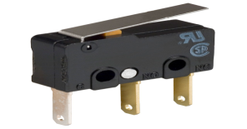

Fig. 4.4.1 Limit Switch

* 1. **LDR SENSOR**

LDR is also referred to as a photoresistor, photocell, or photoconductor. It is a specific kind of resistor, and the amount of light that strikes its surface affects how much resistance it exhibits. A light dependent resistor or LDR is an example of an electrical component that responds to light. When light beams strike it, the resistance changes right away. An LDR’s resistance level can vary by several orders of magnitude. As the light level rises, the resistance value will decrease. LDR resistance values range from many megaohms in complete darkness to only a few hundred ohms in strong light. As a result, these resistors are widely used in a variety of applications due to this variation in resistance. The wavelength of the incident light affects the LDR sensitivity as well.

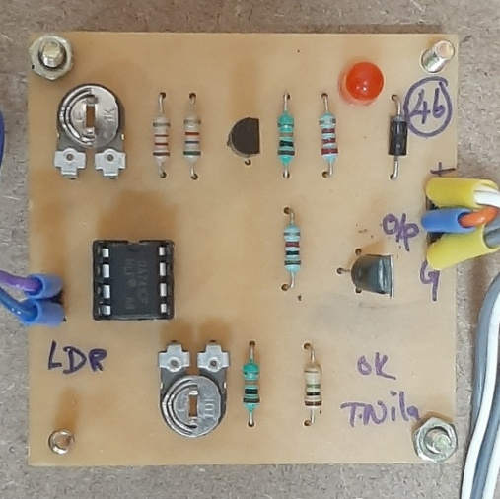

Fig. 4.5.1 LDR sensor

* 1. **RFID (RADIO FREQUENCY IDENTIFICATION)**

This technology is similar in concept to a cell phone RFID is a board term for technologies that use radio waves to automatically identify people or objects. There are several methods of identification, but the most common is to store a serial number that identifies a person or object, and perhaps other information, on a microchip that is attached to an antenna (the chip and the antenna together are called an RFID transponder or an RFID tag). The antenna enables the chip to transmit the identification information to a reader. The reader converts the radio waves back from the RFID tag into digital information that can then be passed on to computers that can make use of it.

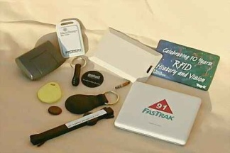

Fig. 4.6.1 RFID Reader

* 1. **KEYBOARD ENCODER**

Keyboard encoder IC to generate BCD code for every key passing. It is a keyboard entry device to Binary coded decimal encoder. It is a part of our project system’s input device. It contains 18 pins IC 74C922, press button assembly having 12 nos. Of buttons. For every button press parallel BCD output goes to micro controller. This will be interlocked with the input card entry device with password facility as a security point of view. It contains 18 pins IC 74C922, press button assemble having 12 nos. Of buttons. After inserting the input card entry, necessary car desk’s password numbers have to be pressed on the press button assembly. For every button press parallel BCD output goes to micro controller via pins nos: 1,2,17 and 18 of IC 74C922. IC74C922 operates under crystal frequency of 4MHZ.

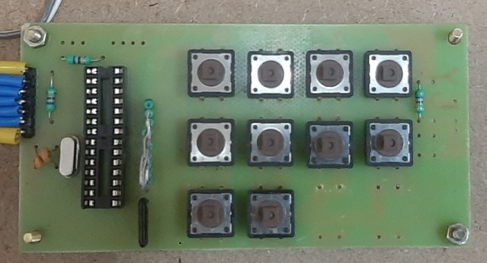

Fig. 4.7.1 Keyboard Encoder

* 1. **BUZZER**

The piezoelectric type uses the piezoelectric ceramic’s piezoelectric effect and pulse current to make the metal plate vibrate and generate sound. This kind of buzzer is made with a resonance box, multi resonator, piezoelectric plate, housing, impedance matcher, etc. Some of the buzzers are also designed with LEDs. The multi resonator of this mainly includes ICs and transistors. Once the supply is given to this resonator, it will oscillate and generated an audio signal with 1.5 to 2 KHz. The impedance matcher will force the piezoelectric plate to produce sound.

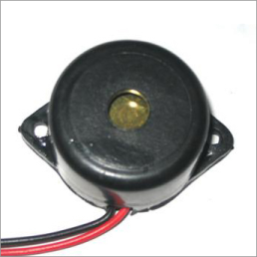

Fig. 4.8.1 Buzzer

* 1. **VOICE BANK**

IC APR 33 is used as the voice bank. The prerecorded messages can be stored in any location. This can be replayed by selecting the respective signal. The output of this IC is given to the power amplifier circuit. The aPR33A series are powerful audio processor along with high performance audio analog –tp-digital converters (ADCs) and digital-to-analog converters (DACs). The aPR33A series are a fully integrated solution offering high processing and analog output functionality. The aPR33A series incorporates all the functionality required to perform demanding audio/voice application.

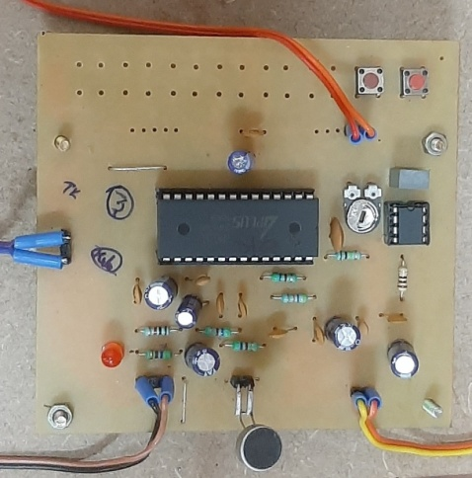

Fig. 4.9.1 Voice Bank

* 1. **LCD DISPLAY**

LCD is essentially used for expose the information. Here we are using 2x16 LCD. It is used to display numbers, texts and graphics. This is in contrast to LEDs, which are limited to numbers and characters. The LCDs are fragile with only a few millimeter thickness. Since the LCDs utilize less power, the y are efficient with low power electronic circuits, and can be charged for long terms. The LCDs don’t provoke light and so light is needed to read the display. The LCDs have long lasting life and a wide operating temperature range.

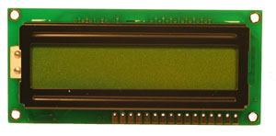

Fig. 4.10.1 LCD Display

**CHAPTER 5**

**RESULTS AND DISCUSSION**

**5.1 RESULTS**

Abduction of neonate from the hospitals using the RFID technology is successfully explained and implemented. This model helps in differentiating the authorized and unauthorized person, by providing the access to authorized to handle the neonate.

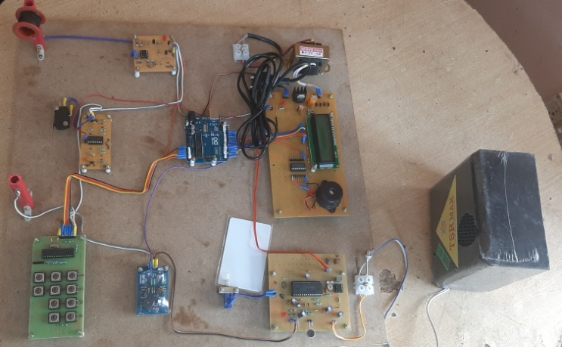

Fig. 5.1.1 Implemented Prototype

The figure 5.1.2 & 5.1.3 depicts the system authorization to handle the baby.

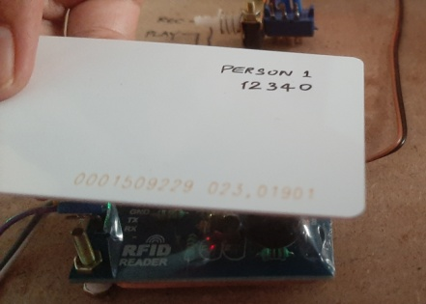

Fig. 5.1.2

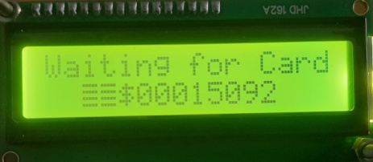

Fig. 5.1.3

**Figure 5.1.2 & 5.1.3 LCD displaying the information for RFID tag verification**

If the tag is authenticated pass key should be entered. The figure 5.1.4, 5.1.5 & 5.1.6 depicts the same,

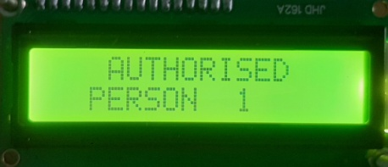

Fig. 5.1.4 LCD displaying the authorized person

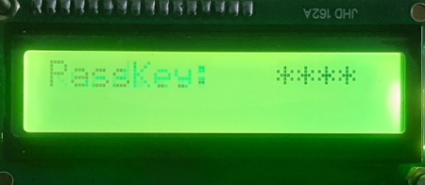

Fig. 5.1.5 LCD displaying the passkey window

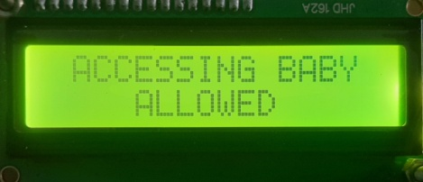

Fig. 5.1.6 LCD displaying the verification completion process

If the tag is not authenticated or if someone is trying to abduct the neonate, the buzzer is set on. The figure 5.1.7, 5.1.8 & 5.1.9 are depicted, LCD displaying the denial of authority, Buzzer and Speaker.

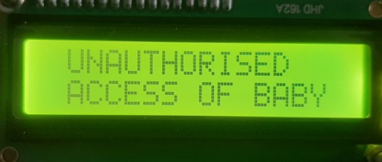

Fig. 5.1.7 LCD displaying the denial of authority

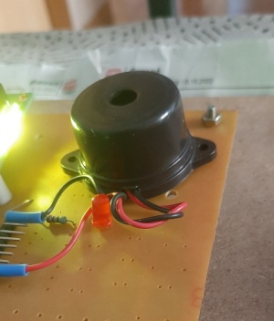 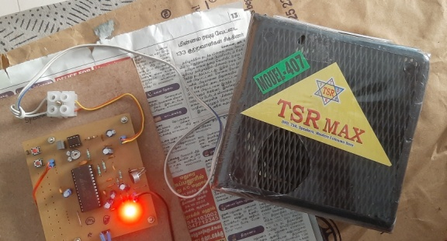

Fig. 5.1.8 Buzzer Fig. 5.1.9 Speaker

**5.2** **COST ESTIMATION**

|  |  |
| --- | --- |
| **COMPONENTS** | **COST** |
| Microcontroller with LCD | 1500 |
| Voice bank | 1000 |
| RFID reader | 2000 |
| Keyboard encoder | 300 |
| Limit switch Debouncer | 750 |
| Limit switch | 250 |
| LDR sensor | 150 |
| Buzzer | 120 |
| Wooden base and others | 1500 |
| **TOTAL** | **7570** |

**CHAPTER 6**

**CONCLUSION**

The present work is an attempt to explore and describe the basic architecture of neonate protection using RFID. A set of two RFID active tag is being provided to the authority with same ID for a neonate. Limit Switch senses the presence of the baby in the cradle, places at the bottom of the cradle. LDR sensor emits the light rays at the top of the cradle. If someone wants to handle the baby, RFID should be authenticated along with password. If not, the security system is turned on. The above system will stop any attempt of cradle abduct and exchange.

**CHAPTER 7**

**REFERENCES**

[1] KAmaraj.A., Sundaram,C., Shobana,G., (2018). Low cost child Abduction Prevention with RFID technology. Indian journal of Public Health Research and Development. 9.2001.10.5958/0976-55062018.01930.7

[2] Hassan, Syed, Alkorji, Ahmed. (2014). RFID based protection to newborns in the hospitals. ISOR Journal of Computer Engineering (ISOR-JCE) e-ISSN:2278-0661, p-ISSN:2278-8727 Volume 16, Issue 3, ER.I (May-Jun.2014), PP 28-32.

[3] Cheng, SH.(2012). An Intelligently Remote Infant Monitoring System Based on RFID. In: Pan, JS., Chen, SM., Nguyen. N.T. (eds) Intelligently information and Database Systems. ACIIDS2012. Lecture notes in Computer Science, vol 7196. Springer, Berlin, Heidelberg.

[https://doi.org/10.1007/978-3-642-28487-8 25](https://doi.org/10.1007/978-3-642-28487-8%2025).

[4] Lin,L., Yu, N., Wang, T., Zhan, C.(@011). Active RFID Based Infant Security System. In: Ma, M.(eds) Communication Systems and Information Technology. Lecture notes in Electrical Engineering, vol 100. Springer, Berlinn, Heidelberg.

[https://doi/org/10.1007/978-3-642-21762-3 26](https://doi/org/10.1007/978-3-642-21762-3%2026).

[5] Azevedo, Susana and Carvalho, Helena and Cruz Machado, Virgilio.(2014). RFID Application Infant Security Systems of Healthcare Organizations. Advances in Intelligent Systems and Computing. 281.10.1008/978-3-642-55122-1_92.

[6] Lin Lin, Nan Yu, Tao Wang, Changan Zhan. Active RFID Based Infant Security System. Communication Systems and Information Technology, 2011, Volume 100 ISBN: 978-3-642-21761-1.

[7] Pablo Picazo-Sanchez, Nasour Bagheri, Pedro-Lopez and Juan E. Tapiador, Two RFID Standard-based Security Protocols for Healthcare Environments. Journal of Medical Systems, 2013, Volume 37, Number 5. DOI: 10.1007/s10916-013-9962-3.

[8] Keerti Srivastava, Amit K. Awasthi, Sonam D. Kaul and R.C Mittal. AHash Based Mutual RFID Tag Authentication Protocol in Telecare Medicine Information System. Journal of Medical Systems, 2015, Volume 39, Number 1. DOI: 10.1007/s10916-014-0153-7.

[9] D Wyld. Preventing the Worst Case Scenario: An Analysis of RFID Technology and Infant Protection in Hospitals. The Internet Journal of Healthcare Administration. 2009. Volume 7 Number 1.

**CHAPTER 8**

**PUBLICATION**

